Lembar Jawab Latihan Pengamatan XI

Nama: Johan Alda, Yosef Resi, Nathanael Orvin, Samuel Eddiajnto

Nim: 71150006, 71150011, 71150025, 71150044

1. 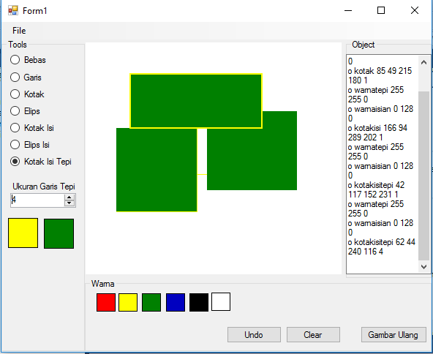
2. Pada PictureBox1_MoveUp digantikan menjadi

If (titik.X <> e.X And titik.Y <> e.Y) Then

TextBox1.AppendText("o " + "warnatepi" + " " + warnatepi.R.ToString + " " +

warnatepi.G.ToString + " " + warnatepi.B.ToString & vbNewLine)

TextBox1.AppendText("o " + "warnaisian" + " " + warnaisian.R.ToString + " " + warnaisian.G.ToString + " " + warnaisian.B.ToString & vbNewLine)

TextBox1.AppendText("o " + modegambar + " " + titik.X.ToString + " " +

titik.Y.ToString + " " + e.X.ToString + " " + e.Y.ToString + " " + CStr(tepi.Width) & vbNewLine)

End If

Private Sub btnUndo_Click(sender As System.Object, e As System.EventArgs) Handles btnUndo.Click

If TextBox1.Lines.Length <= 3 Then

TextBox1.Clear()

Else

Dim num As Integer = TextBox1.Lines.Length

Dim newList As List(Of String) = TextBox1.Lines.ToList

newList.RemoveAt(num - 1)

newList.RemoveAt(num - 2)

newList.RemoveAt(num - 3)

newList.RemoveAt(num - 4)

TextBox1.Lines = newList.ToArray

End If

End Sub

1. Case "kotakisitepi"

Dim rect As New Rectangle(titik.X, titik.Y, e.X - titik.X, e.Y - titik.Y)

Using g As Graphics = Graphics.FromImage(PictureBox1.Image)

g.DrawRectangle(tepi, rect)

End Using

Dim rect2 As New Rectangle(titik.X, titik.Y, e.X - titik.X, e.Y - titik.Y)

Using g As Graphics = Graphics.FromImage(PictureBox1.Image)

g.FillRectangle(isian, rect2)

End Using